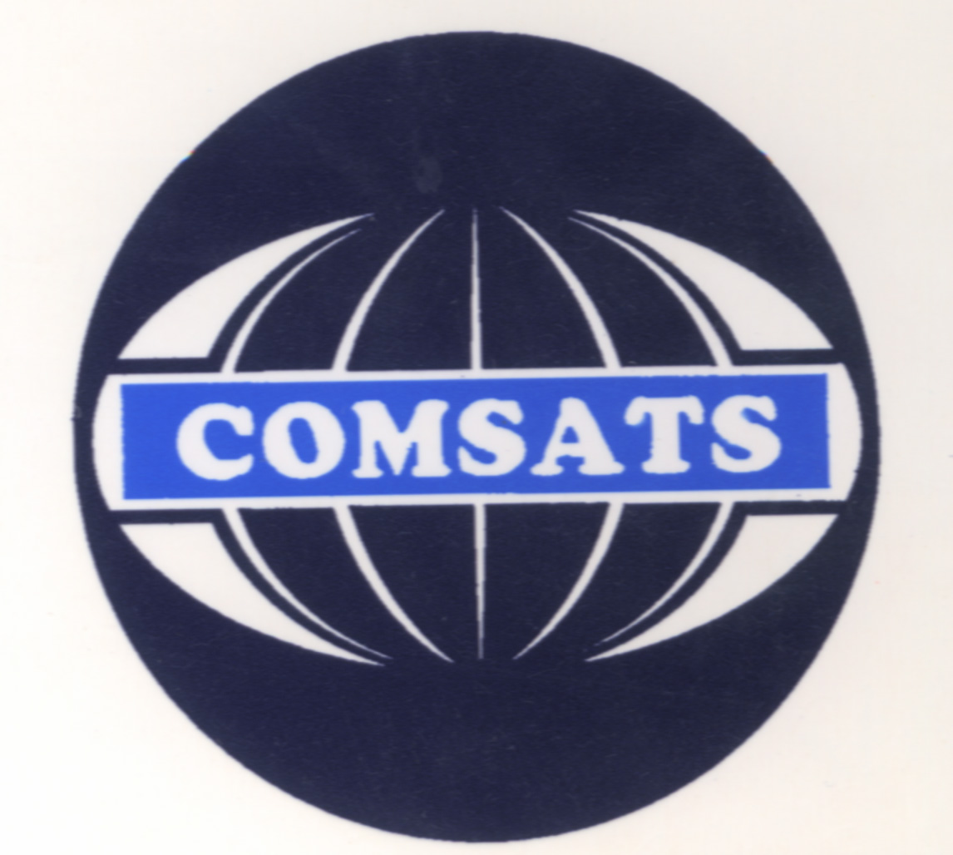
COMSATS Institute of Information Technology
Abbottabad

Course Plan

Semester Spring 2022
Programming Fundamentals
Class: BCS 2B
Course Code: CSC 103
By: Yasher Ali

Total Credit Hours: 4 | Lectures Credit Hours: 3 | Lab. Credit Hours: 1
Total Contact Hours: 6 | Lecture Contact Hours: 3 | Lab. Contact Hours:3

Office Hours (Day, time and place): Date and time will be communicated later

Pre-Requisite: Nil

Course Objectives

Computer programming is by its nature inherently mathematical. Learning a programming language is challenging and difficult and hard work for most students but upon completing this course the students should be able to understand the basic concepts related to programming. Students should also be able to describe, analyze and use the various mechanisms in programming language; e.g. data types, scope, control structures, subprograms, etc. Moreover the students should be able to use the major programming paradigms which include functional and logical.

Note: The contents may be revised, if deemed necessary after the first Sessional test.

Course Outline and Contents
Week | Lecture | Topic Covered | Date / Time Delivered
Week-1 | Lecture#1 | Why programming languages, steps to learn a programming language, variables, constants, and keywords
Week-1 | Lecture#2 | Data types, escape sequences, format specifiers
Week-2 | Lecture#3 | Input and output statements
Week-2 | Lecture#4 | Arithmetic operators
Week -3 | Lecture # 5 | Arithmetic assignment and operators precedence
Week -3 | Lecture # 6 | Relational operators, logical operators, precedence, assignment operator, postfix and prefix increment and decrement operators
Week -4 | Lecture # 7 | Conditional Structures: One-way selection using the if-statement, Two-way Selection Using the if-else statement, relational and logical operators use in decision control structures with example programs
Week -4 | Lecture # 8 | Multiple alternative decisions using the nested if-else statements, multiple selection using the switch statement, with example programs, flow charts, standard library functions
Week - 5 | Lecture # 9 | Loops: Introduction to repetition structures, repetition essentials, counter controlled repetition, for statement, examples using for statement, nested for loops
Week - 5 | Lecture # 10 | While statement, do while repetition statement, break and continue statements, use of logical operators in while statement
Week - 6 | Lecture # 11 | Functions: introduction and overview, function definitions, function prototypes
Week - 6 | Lecture # 12 | Local and global variables and their application in different programs
Week - 7 | Lecture # 13 | Arrays: overview, declaring and referencing 1-D array, using for loops for accessing 1-D array elements, programming examples of arrays
Week - 7 | Lecture # 14 | Using arrays with functions, referring to individual elements of the array with programming examples
Week - 8 | Lecture # 15 | Searching, sorting, insertion & deletion in 1-D Array
Week - 8 | Lecture # 16 | Strings: overview, fundamentals of strings and characters, string input/output
Week - 9 | Lecture # 17 | String manipulation and comparison functions of the string handling library and other functions
Week - 9 | Lecture # 18 | Pointers: overview of pointers, pointer variable definition and initialization, pointer operators, calling functions by reference
Week - 10 | Lecture # 19 | Pointer expressions and pointer arithmetic, relationship between pointers and arrays, using pointers with functions
Week - 10 | Lecture # 20 | 2-D arrays in detail with examples and applications
Week - 11 | Lecture # 21 | Structures: overview and introduction, structure definitions, initialization of structures, accessing members of structures
Week - 11 | Lecture # 22 | Using structures with functions and arrays
Week - 12 | Lecture # 23 | Structures as parameters and return values of functions, some example applications
Week - 12 | Lecture # 24 | C Preprocessor: #define directive symbolic constants, #define directive macros etc.
Week -13 | Lecture # 25 | Recursion: concept with practical examples
Week -13 | Lecture # 26 | Storage classes: automatic storage class, static storage class, register storage class, and external storage class
Week - 14 | Lecture # 27 | Enumerated data types, typedef, identifier and naming classes, type conversion, basics of graphics
Week - 14 | Lecture # 28 | Disk Files: Overview and introduction about data files, Important Statements/Functions for handling I/O Data files
Week - 15 | Lecture # 29 | Files and streams, creating a sequential access file, creating Random access files, reading and writing in files
Week - 15 | Lecture # 30 | Projects discussion: Sample Case Study
Week -16 | Lecture # 31 | Sessionals
Week -16 | Lecture # 32 | Sessionals

Recommended Books:
- C How to Program by Dietel & Dietel (Latest Edition)
- Turbo C Programming for the PC by Robert Lafore

Recommended Compiler:
- Dev-C++

